GCDS Members Are 2021 ADS Photography Contest Winners!

Each year the American Dahlia Society holds a photo contest. In 2021 there were over 450 entries in nine different categories.

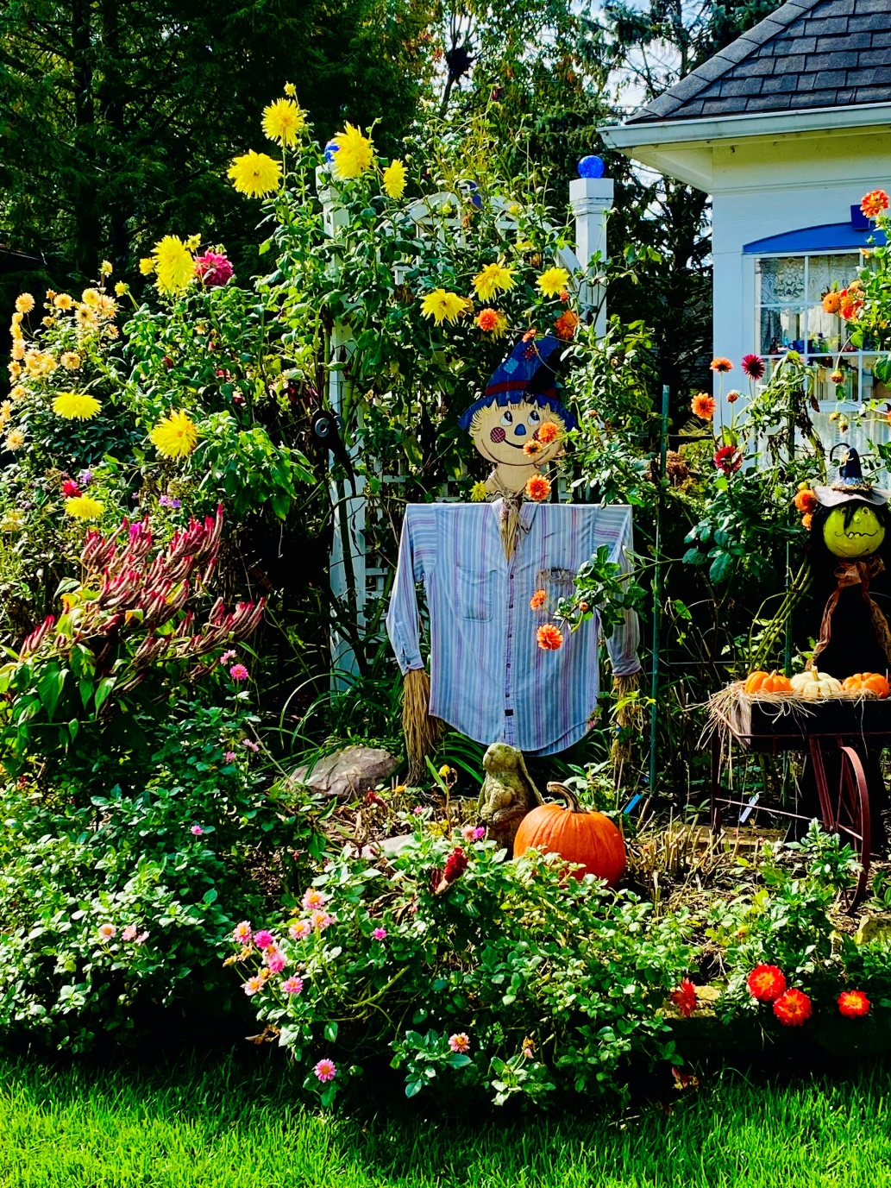
Linda Laine was awarded first place for her photo of a dahlia garden (her own).

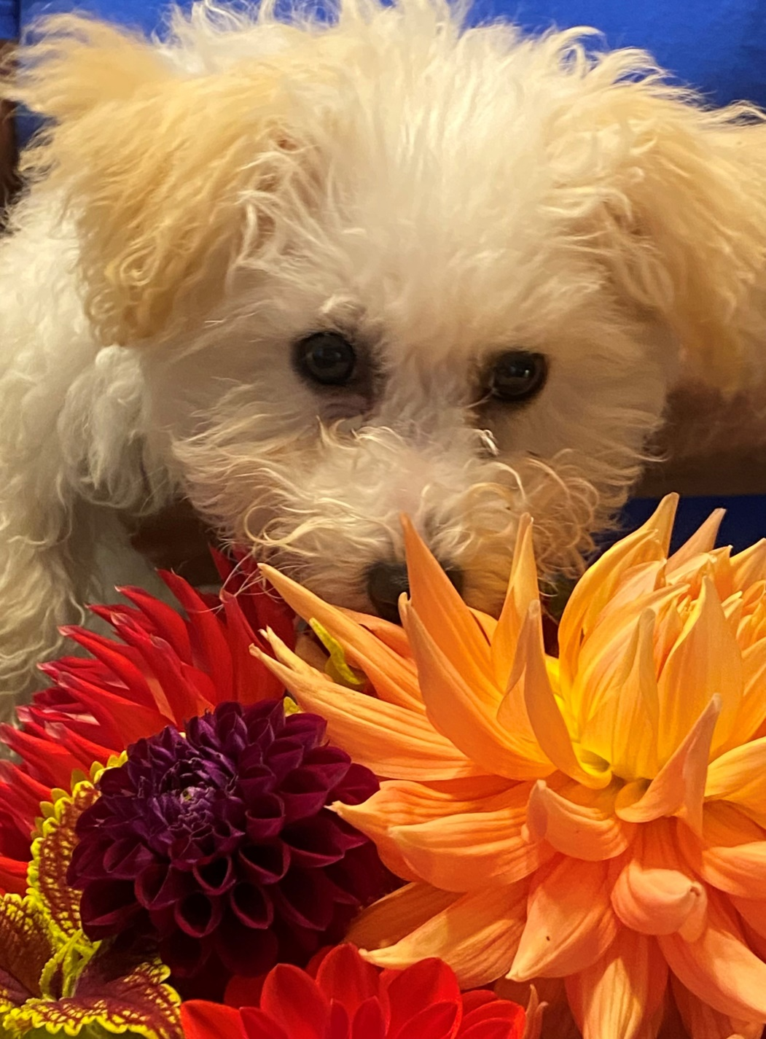
And she earned second place in the “Critters” category for her photo of her dog, “Whisper”, hiding behind some dahlias.

Jeff Laine was awarded third place in the “Shows and Personalities” category with his photo of Linda at the 2021 National ADS Show.
