On July 25, 2021 Dick and Peg presented Gil Graham with the American Dahlia Society Medal in honor of all the work that he has done for our society, especially for his work in managing the root and plant sale by himself during the pandemic, the set-up of the honor table at our show, and managing the layout of the tables at the show. Also, he has done a tremendous job making the posters that are given to our sponsors and are also used to promote our show.

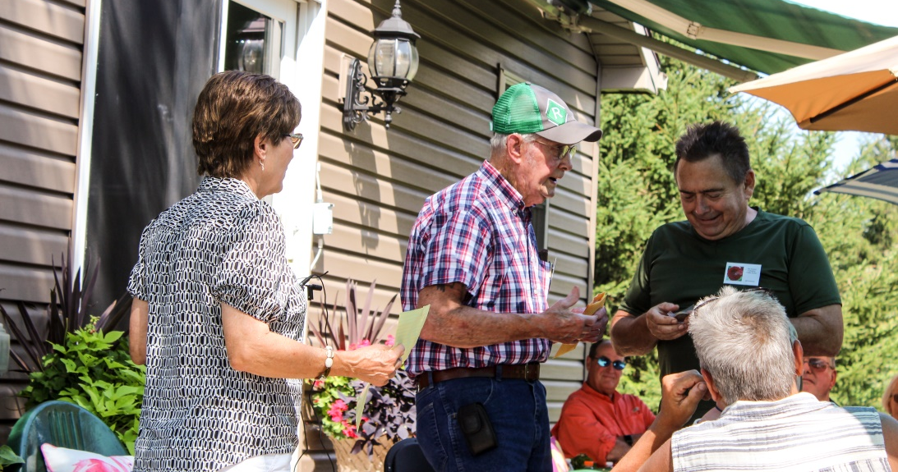

Dick and Peg also presented Jeff and Linda Laine with the American Dahlia Society Medal for all the work they do in promoting our Society, managing the web site and many other things including being candidate judges.
